Week 2: Customize Gifts – Product and Category Management System
Scenario:
The e-commerce company wants to maintain information about customized gifts and their categories. Each product belongs to a specific category, and the system manages product details such as product name, price, and stock availability.
The categories include:
- Birthday Party
- Anniversary
- Baby Shower
- Wedding
- Housewarming
- Graduation
1. Design Product and Category Tables
Category Table:
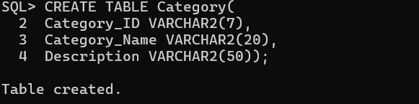
Product Table: 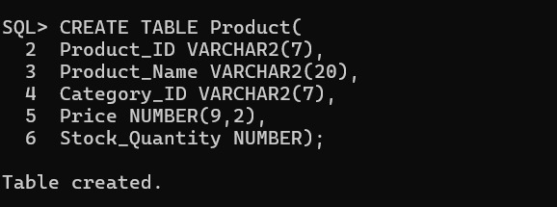

The two tables Category and Product have been created.
2. Define Relationships and Constraints
Relationship:
One category can have many products.
Therefore, the relationship between Category and Product is:
*One-to-Many (1 → )
For example, the Birthday Party category can contain many customized gifts.
Primary Key: A Primary Key uniquely identifies each record.
In the Category table:
CATEGORY_ID is the Primary Key.
In the Product table:
PRODUCT_ID is the Primary Key.
Foreign Key: A Foreign Key is used to link two tables.
In our project:
PRODUCT.CATEGORY_ID CATEGORY.CATEGORY_ID
Therefore, CATEGORY_ID in the Product table acts as the Foreign Key.
Primary key:
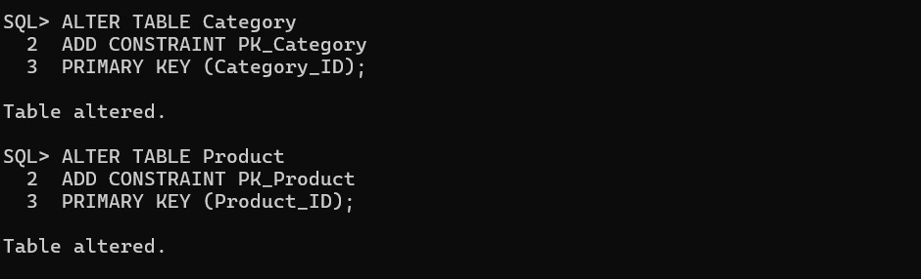
Creating Foreign Key 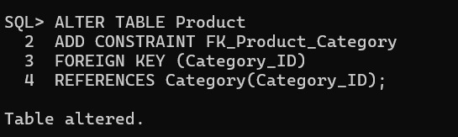
Adding Constraints
NOT NULL:
NOT NULL ensures that the column cannot have an empty value.
For our project, Category Name and Product Name cannot be empty.
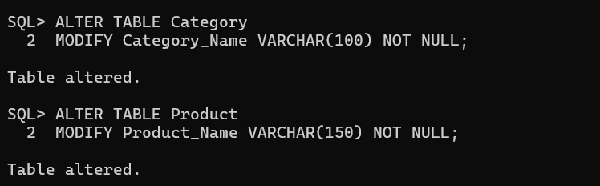
CHECK
CHECK validates values based on a condition.
The product price must be greater than zero and stock cannot be negative.
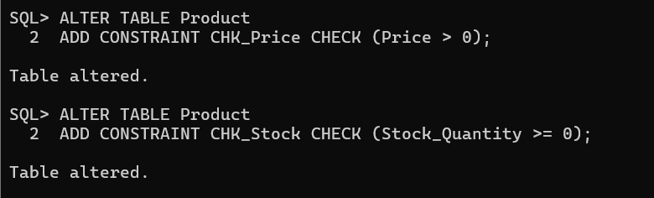
UNIQUE
UNIQUE ensures that duplicate values are not allowed.
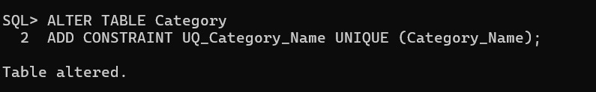

3. Insert Values:
Category Table:
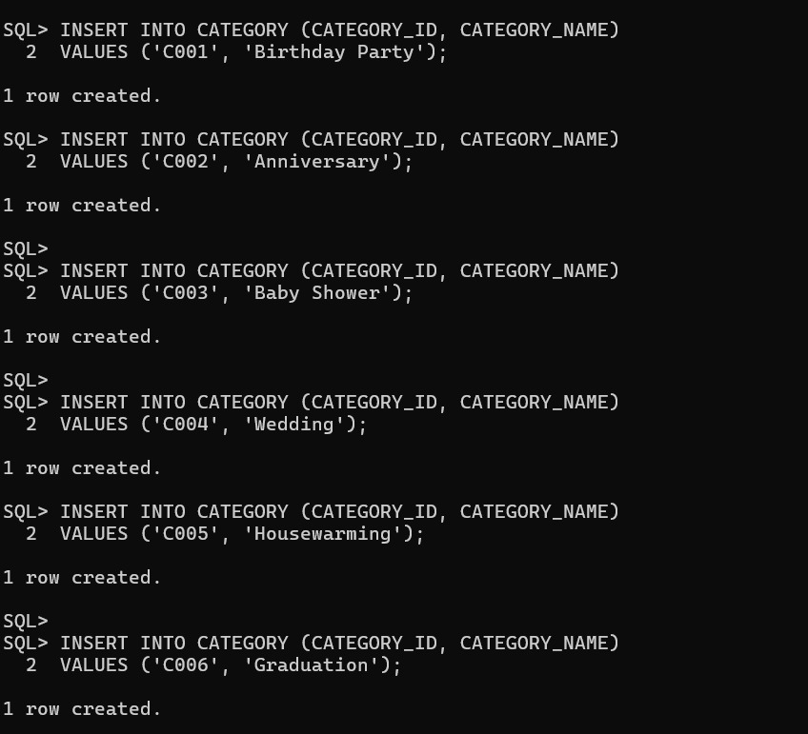
Product Table: 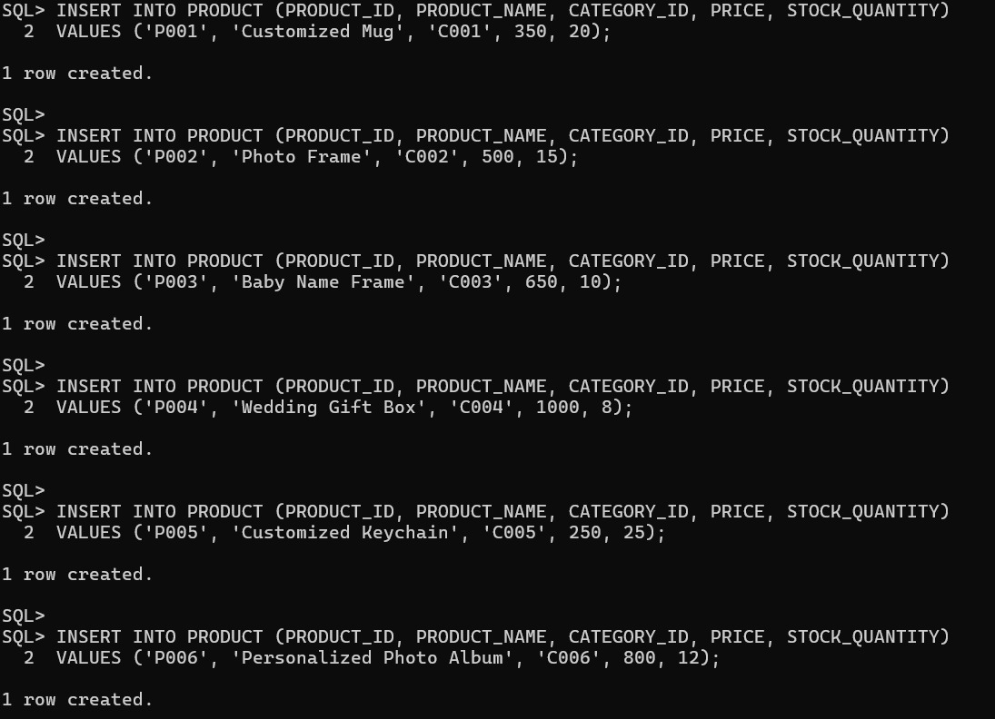
After insertion category table:
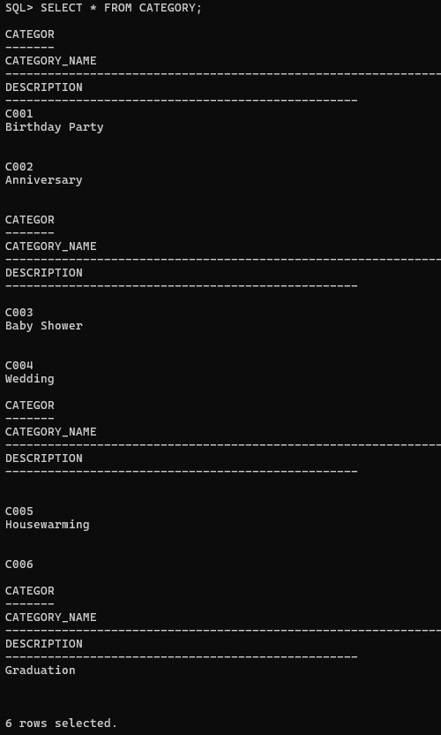
Product table:
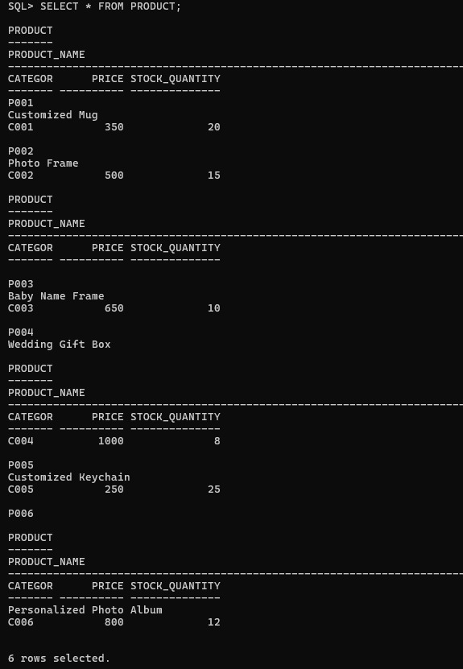
4. CRUD Operations:
Insert Record

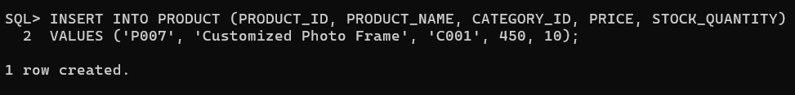
Update Price

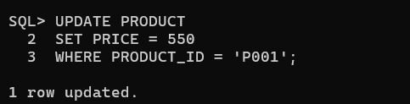
Delete a Product

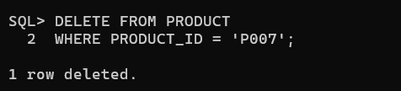

5. Generate Category-wise Product Reports
1. Display all products under each category
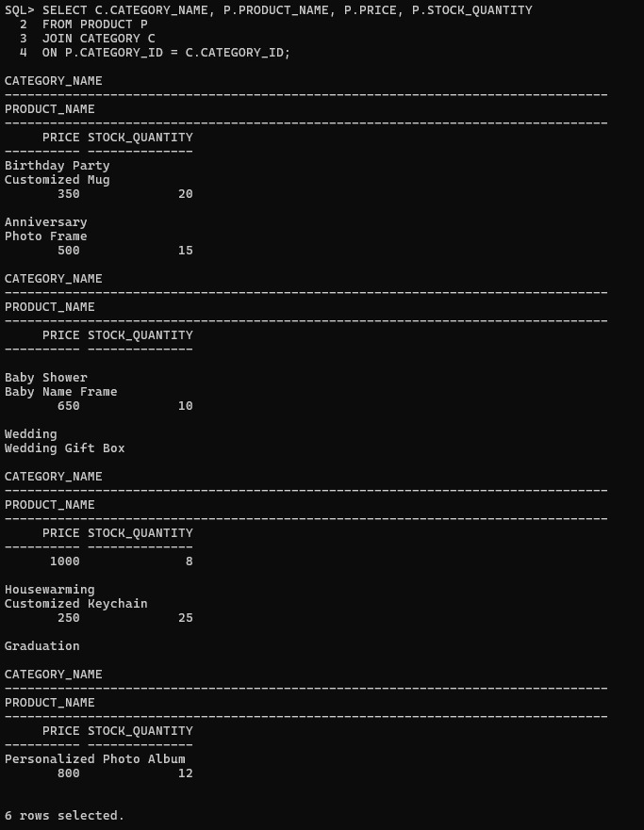

2. Count number of products in each category 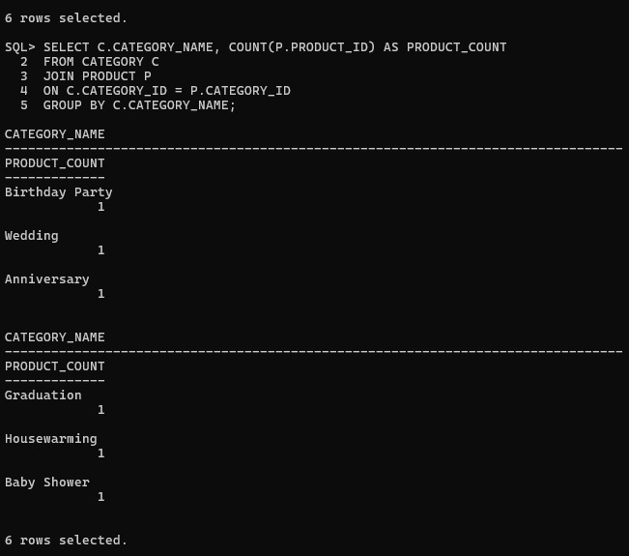
3. Find highest-priced product in each category 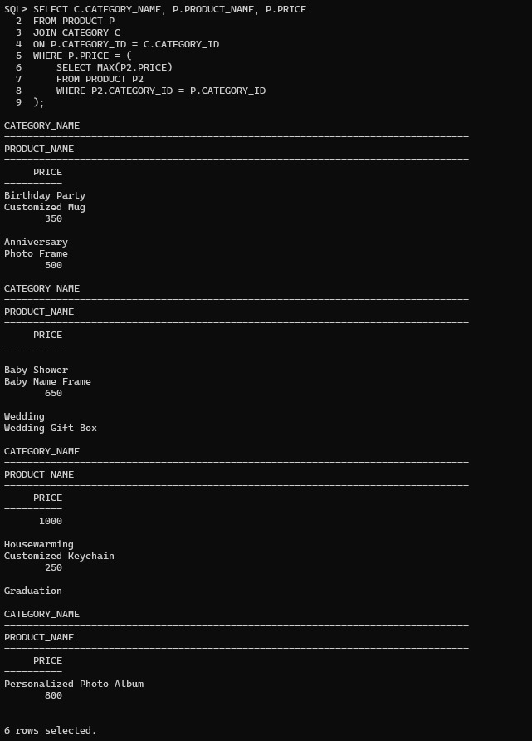

4. Display categories having more than 5 products
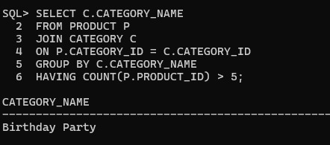
5. Find average product price category-wise
